12.74: Using conservation of energy,

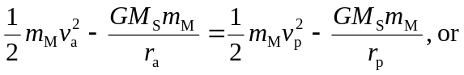
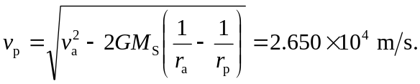

The subscripts a and p denote aphelion and perihelion.
To use conservation of angular momentum, note that at the extremes of distance (periheleion and aphelion), Mars’ velocity vector must be perpendicular to its radius vector, and so the magnitude of the angular momentum is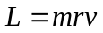. Since L is constant, the product must be a constant, and so

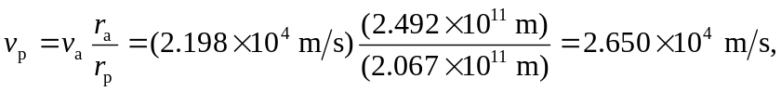

a confirmation of Kepler’s Laws.

